* **@OneToOne**
  + **Using a foreign key**

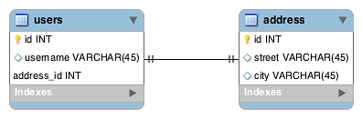

*the address_id column in users is the foreign key to address.*

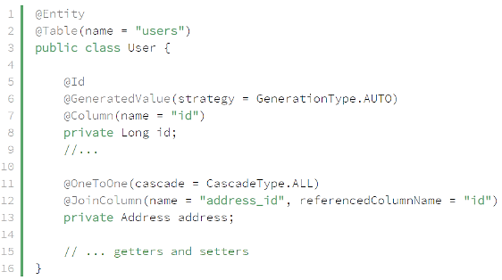 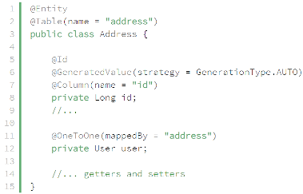

*mappedBy address which is variable in Java*

* + **Using a Shared Primary Key**

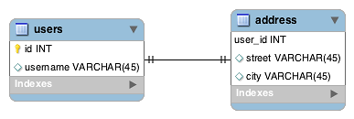

*the user_id column in address is the foreign key to user*

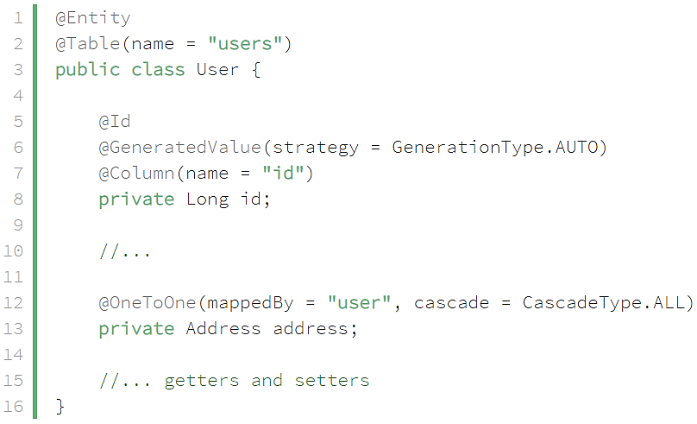 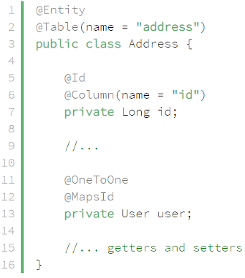

*@MapsId: the id column of address as both primary key and foreign key.*

* + **Join table** (chủ yếu sử dụng cho many to many)

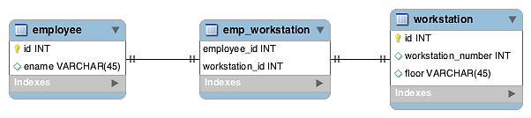

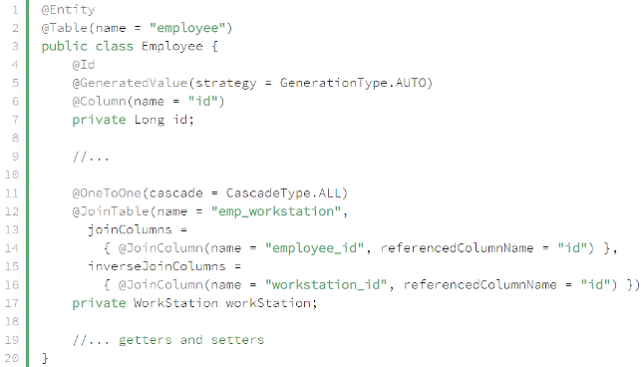 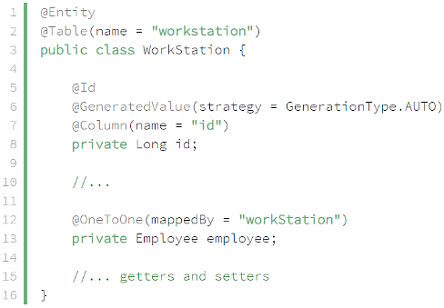

* **Reference**

<https://www.baeldung.com/jpa-one-to-one>